http://www.castorama.fr/store/Miroir-eclairant-Cristo-65x50-cm-PRDm574373.html?navCount=12&navAction=jump&categoryId=cat_id_3369&skuId=Casto574373
56

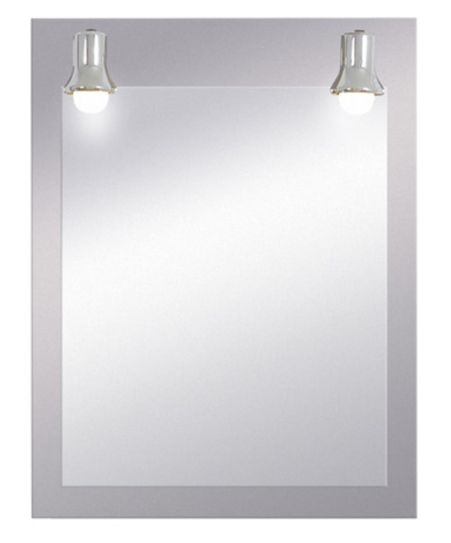

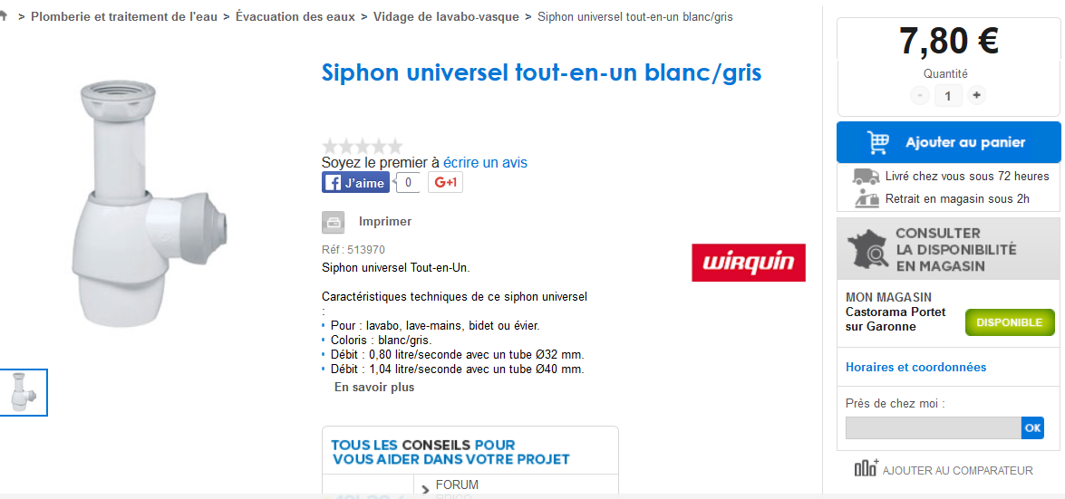

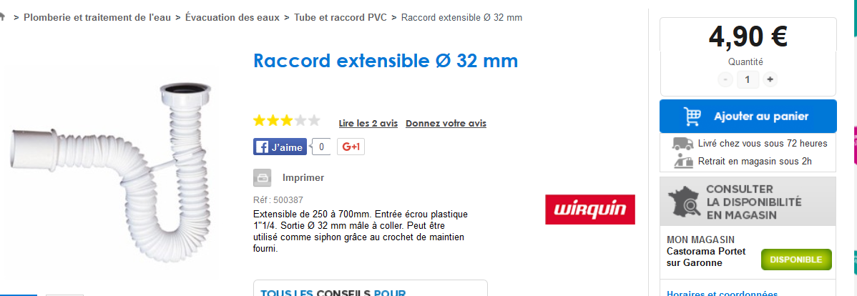

Raccord sans soudure
Robinet d’arrêt
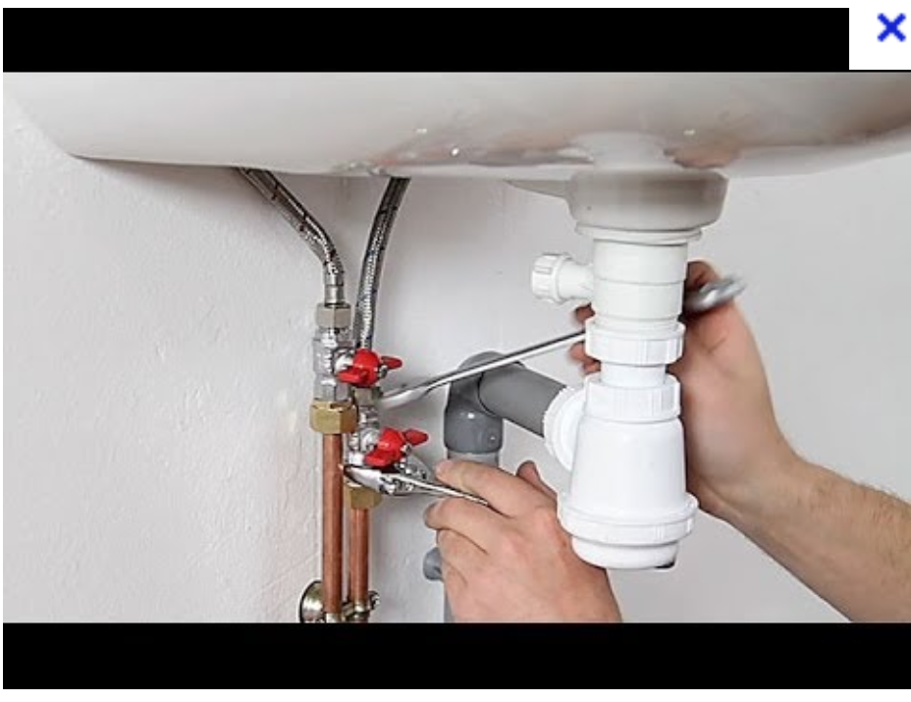

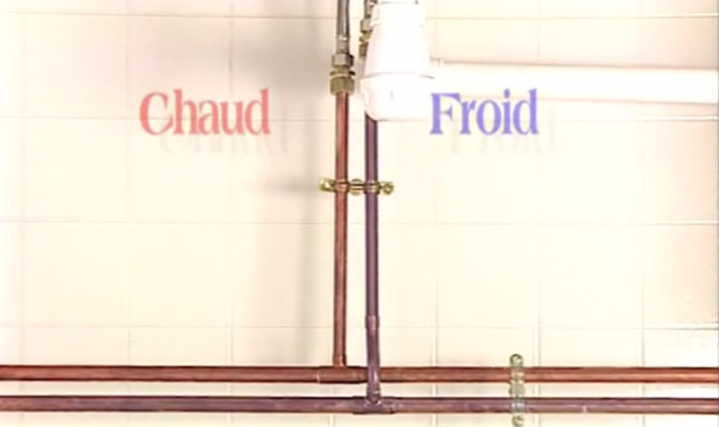
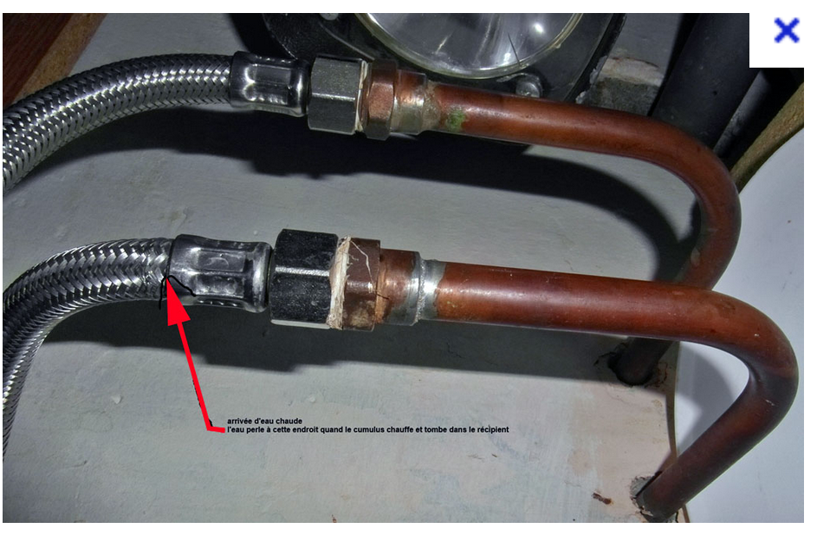

https://www.youtube.com/watch?v=O55PkKAeVtc

http://www.castorama.fr/store/Applique-pour
https://www.youtube.com/watch?v=92uzV5jX2hI
https://www.youtube.com/watch?v=92uzV5jX2hI

miroir-Salle-de-bains-Tora-IP44-G9-28W-prod17810032.html?navCount=4&sortByValue=relevance&navAction=push

35

http://www.castorama.fr/store/Miroir-eclairant-decor-chene-naturel-60-cm-Calao-prod13200010.html?isFeaturedProduct=true&navCount=0&navAction=jump&categoryId=cat_id_3369#
85
http://www.castorama.fr/store/Miroir-eclairant-Souto-65x50-cm-PRDm580525.html?navCount=8&sortByValue=relevance&navAction=push
40

http://www.castorama.fr/store/Miroir-Tinn-50-cm-prod16150070.html?navCount=11&sortByValue=lowHighPrice&navAction=push
45

http://www.leroymerlin.fr/v3/p/produits/salle-de-bains/accessoires-et-miroirs-de-salle-de-bains/spot-pour-miroir-l1308217465

